North Carolina Migrant Education Program
2019-20 Prospective Re-Interview Report

Prepared for:
North Carolina Department of Education
Migrant Education Program

Prepared by:
Will Messier
Arroyo Research Services

December 2020

Table of Contents

Introduction 1

Methodology 1

Develop Sampling Plan 2

Develop/Modify Re-interview Form and Protocol 3

Identify and Prepare the Independent Re-interviewers 3

Interview Families 3

Review Re-interview Forms to Validate Determinations Using an

Independent Review Panel 3

Provide Due Process to Challenge Review Panel Determinations 4

Report Limitations, Results and Recommendations 4

Limitations 4

Preliminary Results 5

Response Rate 5

Initial Eligibility Determinations 6

COE Completion Errors 6

Not Eligible 7

Re-interview Outcomes 7

Recommendations 7

Summary 8

Appendices

Appendix A – Re-interview Form 9

Appendix B – Information for CSPR Part II, Section 2.4.3 11

Introduction

The U.S. Department of Education, Office of Migrant Education (OME) requires state education agencies (SEAs) to implement quality control procedures to ensure the timely and proper identification of migrant children and youth. Since 2008, one of the procedures required by the OME to validate eligibility determinations is the annual re-interviewing of families, children, and youth currently deemed eligible by the SEAs. The OME requires that the re-interview is conducted using independent, external re-interviewers every third year [CFR, Section 200.89 (b)(2)]. Also, the results of the re-interview process identify procedures in identification and recruitment (ID&R) of migrant children and training practices in ID&R that need improvement.

The Office of Migrant Education, Department of Education, provided updated regulations for the re-interview process on November 22, 2019. The changes, posted in the Federal Register, included the following:
- Clarify that the individuals conducting prospective re-interviews must be individuals who did not conduct the initial interview.
- Replace the term “current year” with “current performance period” as related to eligibility determinations. In the MEP, a performance period is identified as the time from September 1 through August 31 of the following year.
- Modify the requirement for external interviews being conducted at least once every three years. The new regulations require the use of independent re-interviewers at least once until September 1, 2020. After September 1, 2020, SEAs are required to use independent re-interviewers within the first three performance periods following the effective date of any major statutory or regulatory that impact program eligibility.

(Federal Register /Vol. 84, No. 226 / Friday, November 22, 2019 /Rules and Regulations)

This report describes the efforts of the North Carolina Migrant Education Program (NC MEP) and Arroyo, as a contractor, to validate and corroborate the eligibility of migrant families and youth in the state. The findings of this process will be used by the NC MEP to improve their ID&R practices through the implementation of enhanced strategies and procedures for ensuring proper eligibility determinations.

This report includes the methodology used while conducting the interviews, the initial findings, and the response rate. In addition, this report includes the final results of the study and the discrepancy rate, as well as information to be reported by the NC MEP on the Consolidated State Performance Report, Part II.

Methodology

Arroyo implemented the following steps to conduct the re-interviews of migrant families in SEA:
- Develop sampling plan
- Develop/modify re-interview form and protocol
- Identify and prepare the independent re-interviewer
- Interview families
- Review re-interview forms to validate determinations using an independent review panel
- Provide due process to challenge review determinations
- Calculate response rate and discrepancy rate
- Report findings and recommendations

Develop Sampling Plan
Arroyo reviewed the state's migrant excel report of new COE’s completed for children 3-21 years of age in coordination with the NC MEP Staff to ascertain the estimated numbers of migrant children residing in SEA. It was determined that the sample for this study would be selected from the universe of migrant children, ages 3-21, for whom a new COE had been completed during the current performance period (September 1, 2019, to August 31, 2020). The interviews were conducted September 5-21, 2020, after the performance period was over
The SEA provided the necessary data to Arroyo via a secure server and asked the independent re-interviewer to draw the random sample. Listed below is the process the Arroyo utilized to generate the random sample external re-interview.
- Arroyo received an excel report of all students (ages 3-21) newly recruited (COE sign date) in the NC MEP from September 1, 2019, to August 31, 2020.
- Based on the universe report, Arroyo utilized a random number generator in Excel to assign a random number to each child and then sorted the random numbers from least to greatest.
- The first 150 students were selected for the re-interview study.
  - Sample numbers 1 to 50 were assigned as the primary interview (List 1).
  - Sample numbers 51 to 150 were assigned as the alternate/replacement (List 2).
- Arroyo password protected the Excel spreadsheet and provided the document to the SEA MEP via a secure server.
The use of this sampling method guaranteed that every migrant child in the state who met the criteria had the same probability of being selected for this study's sample. The data for each sample included the following demographic information:
- child’s first and last name,
- the qualifying arrival date [QAD],
- county/district,
- physical address,
- phone number,
- date of birth,
- grade,
- parent/guardian names, and
- established worker move date).
After the random sample was selected, the NC MEP transmitted protected copies of the corresponding COEs for students in List 1 and List 2 to Arroyo via the state’s secure file share system.

Develop/Modify Re-interview Form and Protocol

The re-interview form complies with current OME regulations and requirements for interviewing migrant families. The target date is the QAD on the COE that was used to make an eligibility determination. The re-interviewer was instructed to complete the re-interview form with the information obtained from the interviewee and using the target QAD as the baseline date for the interview. A copy of the re-interview form is included in Appendix A.
Identify and Prepare the Independent Re-interviewers

One independent re-interviewer was utilized from New York State for the NC MEP re-interview process. The re-interviewer is an experienced recruiter in his/her respective state.

The re-interviewer and the Arroyo project lead met on September 3rd, 2020 to discuss the re-interview protocol and the basic eligibility factors as well as any state-specific issues involving eligibility.

The Arroyo project lead developed electronic copies of the re-interview forms and shared these with the re-interviewer during the September 3, 2020 meeting. The re-interviewer also received an excel spreadsheet sorted by district with demographic information (sample number, sample first and last name, QAD, district, physical address, phone number, date of birth, grade, and parent/guardian names) for the list of children in the sample (List 1) and the replacement names (List 2).

Interview Families

Because of limitations due to Covid 19, the re-interviewer was only able to contact the randomly selected sample by phone. The re-interviewer used a phone app called Sideline to secure an NC-based phone number in order to increase response rates. A total of 51 re-interviews were conducted by the independent re-interviewer.

Review Re-interview Forms to Validate Determinations Using an Independent Review Panel

To maintain integrity in the re-interview process, Arroyo enlisted a review panel comprised of three out-of-state independent ID&R experts, all of whom are MEP administrators in their respective states and have previously participated in re-interview efforts. The role of the panel was to examine the forms and compare them to the COEs. Based on their review, the panel was to indicate on a rating sheet if the sample was eligible, if additional information was needed, or if the sample was determined as not eligible.

Reviewers compared COEs with the completed re-interview forms. After all the documents were reviewed and the tally sheets completed, panelists submitted their findings to Arroyo. The review panel initiated their efforts on September 30, 2020, and finished their initial determination review on November 13, 2020.
Provide Due Process to Challenge Review Panel Determinations
Once the review process was completed, Arroyo provided the NC MEP with a preliminary report containing the review panel’s initial eligibility determination. The report was submitted to the NC MEP via the state’s secure server. Copies of the completed re-interview forms and COEs were also provided to the NC MEP via the state’s encrypted communication system. The initial report indicated the type of clarifying information that would assist the reviewers in making a

proper determination. This initial determination report, consisting of a password protected Excel file, was provided to the NC MEP on October 30, 2020.

After receiving the initial determinations, the SEA had time to provide additional clarifying information as to appeal the panel’s determinations. The SEA submitted its appeal information on November 20, 2020.

Report Limitations, Results and Recommendations

Limitations

The study and results are affected by the following limitations:
- Interviews conducted both during the original determination of eligibility and subsequent re-interview efforts depend on the information provided by the interviewee. Although they are well trained, recruiters still must rely on the information and statements provided by the families and youth at the time of the interview.
- Results are limited to children and youth who were identified by the NC MEP and their recruitment staff and were currently eligible at the time of the re-interview.
- Families and/or youth are often unable to be located, necessitating the process to rely on an already randomly selected replacement sample; the study is, therefore, limited by the extent to which the replacement sample resembles the originally selected children.
- Face-to-Face interviews provide the best information to be used to determine eligibility. Due to Covid 19, the re-interviews were restricted to only phone calls. Therefore, the reliability of the information is limited by the extent to which information is obtained through a phone call.
- Fear of immigration and other mitigating factors also contribute to the difficulties of conducting eligibility interviews with migrant families and youth. These factors also affect the re-interview process since respondents might be apprehensive of communicating with a person they do not know or have met.

Preliminary Results

Arroyo analyzed the data in terms of four major areas: response rate, eligibility error rate (also referred to as discrepancy rate), COE completion errors (not affecting eligibility), and additional information needed to make an eligibility determination. The response rate takes into account the number of attempts that were made compared to the total re-interviews completed. The eligibility error rate compares the number of eligible versus not eligible families identified. The COE completion errors identify the COEs that were found to have been written incorrectly (with the error not affecting the eligibility status of the child in the sample). Finally, where indicated, the review panel requested additional information to ascertain the eligibility determination of migrant children.
The independent review panel analysis resulted in the initial eligibility determinations as reported below in Table 1.

Table 1. Initial eligibility determinations by review panel – 51 re-interviews completed
(prior to state and/or local challenge)
 | Eligible | Eligible with COE Errors - Need More Information | Not eligible
NC MEP | 41 | 9 | 1

Response Rate
As shown in Table 2, an analysis of the re-interview logs shows the following patterns of response and non-response.
Table 2. Re-interview response rate (overall sample)
 | Sample Size¹ | Completed  Re-Interviews | Attempted, Not Interviewed² | Not Used³ | Response Rate⁴
Overall | 150 | 51 | 52 | 47 | 49.51%
Main (List 1) | 50 | 32 | 18 | - | 64.0%
Replacement (List 2) | 100 | 19 | 34 | 47
¹ Sample Size equals the number of children identified on the sampling and replacement list.
² Attempted, Not Interviewed includes the children/youth for whom at least one attempt was made, but communication was not established, had moved, or refused to be re-interviewed. It does not include children/youth for whom a re-interview was completed.
³ Not Used designates individuals on the sampling list who were not attempted to be re-interviewed.
⁴ Response Rate is the result of Completed Re-interviews / (Completed Re-Interviews + Attempted Not Interviewed). (Overall response rate = 51/(51+52); List 1 response rate = 32/(32+18)).
The overall response rate for the SEA re-interview was 49.51%. Of the main list, the response rate was significantly better at 64%. A total of 103 interviews were attempted, while a total of 47 children from the sample were not needed. A total of 51 interviews were completed (32 from the original sample and 19 from the replacement sample).
Initial Eligibility Determinations
The expert panel reviewed all 51 re-interview forms, compared these to the original COEs, and provided an initial determination for each sample that was re-interviewed. The panel initially determined 41 of the 51 re-interviews as “eligible.” Nine (9) of the 51 were initially determined to be eligible; however, the panel identified corrections that needed to be added to the original COE and more information was needed. One COE was viewed as not eligible during the initial determination.
COE Completion Errors
As indicated above, the COEs for 9 of the re-interviews have errors that need to be corrected.
- Section III no. 4b - A COE was completed using 4b actively sought qualifying work, and has a history of moves for qualifying work. The criteria for using 4b was not met. In review, 4a should have been utilized for the move made in December of 2018.
- Section 3 no. 5 Temporary or Seasonal – A COE was completed with both boxes checked for both temporary and seasonal qualifying work. The panel believes that the qualifying work in this particular COE is temporary and the length of the temporary job needs to be added.
- Section 3 no. 5 Temporary or Seasonal - Seasonal work was selected for a meat processing plant in a particular COE. The panel recommends that the COE is correct by checking the temporary box and adding that the duration of the qualifying work will be 3 months.
- Sections 3 no. 1 and 4 – A COE included two children that had moved on different dates to move with or to join the migratory agricultural worker (MAW). The panel recommends that two COE’s are completed to document these two different eligibility determinations.
- Section 3 no. 5 – A COE indicated that the qualifying activity is “planting plants.” Please add the actual crops that the MAW was engaged with (including, for this case, planting strawberries, tomatoes and peppers). According to the interview, the work in this particular COE is temporary; therefore, please add the temporary statement indicating employment lasted less than 1 year.
- Section III no. 4b – In another COE, the recruiter incorrectly selected 4b instead of 4a in section III. Per the re-interview form, the MAW engaged in agricultural work (planting pine trees) which will extend eligibility.
- Section 3 no. 5 - In another COE, the qualifying activity of “cutting sod” should replace “transplanting grass”, which is not a qualifying activity.
- Section III no. 4b – The panel determined that the recruiter should have used 4a instead of 4b in another COE since the worker engaged in qualifying work trimming poultry.
- Sections 3 no. 1 and 4 – The panel determined that, in another COE, the most recent move to engage in qualifying work in NC should be used instead of the move to Georgia, which was incorrectly used. This correction will extend eligibility.

Not Eligible
The panel determined one sample as “not eligible.” The COE in question should not have been completed using the documented information. Picking blueberries in Monroe County (South Florida) was not possible. The panel believes that there is a possibility this family may have qualified on a move to another state to pick blueberries. The final determination is the COE was filled out in error, and the sample was “not eligible.”
Re-interview Outcomes
The NC MEP appeal provided Arroyo sufficient documentation to make a final determination for all 51 samples that were re-interviewed. Table 4 delineates the final outcome.
Table 4. Review panel determination (initial and final) and discrepancy rate
 | Eligible | Eligible with COE Errors / Questions | Need More Information |  | Not Eligible
Initial Review Panel Determination | 41 | 0 | 9 |  | 1
Final Determination after Appeal Review | 50 | 0 | 0 |  | 1

Discrepancy Rate
Percent Ineligible (Not Eligible/Total Re-interviews) |  |  |  | 1.9%

Based on the findings from the re-interview team and the results of the appeal process, the study has determined that a proper eligibility determination was made in all 50 of the 51 cases, resulting in a 1.9% discrepancy rate (1/51).

Recommendations

The independent re-interview brought to light that the NC MEP staff view quality control with high regard. Nevertheless, the information obtained by the re-interviewers and the review panel’s observations helps to inform the following quality control recommendations made to assist the NC MEP in refining future ID&R and re-interview efforts, as indicated below.
- Training for NC recruitment staff on the Non-Regulatory Guidance for Title I, Part C, Education of Migratory Children (March 2017) should happen on an annual basis. Emphasis should be given on Section III and differentiating between Qualifying Moves and Migratory Agricultural Worker moves.
- The NC MEP should periodically review quality control processes to avoid COE completion errors.
- The NC MEP should revise any state materials (policy guidance, training modules) related to Qualifying Activities to be more specific and universal.
- Training on both temporary and seasonal work should be highlighted. Using scenarios will allow staff to better understand the nuances of these terms. For MEP purposes, temporary employment must be less than 12 months.
- The comment section should only be used for information that assists staff in determining eligibility. Training on the use of this section would be beneficial to staff.

Summary

The re-interview activity for the NC MEP was conducted during September 5-21, 2020. One out-of-state independent re-interviewer was utilized to conduct phone interviews throughout the state in an attempt to locate at least 50 children or youth from a statewide randomly selected sample of 150 migrant children residing in the state. The re-interviewer was able to communicate with and re-interview 51 families and/or youth in 103 attempts, resulting in a 49.51% response rate.

A review panel comprised of three out-of-state experts in ID&R determined the accuracy of each original eligibility determination for which a re-interview was conducted. The panel’s determinations were shared with the NC MEP that, in turn, provided additional clarifying information requested by the panel. Following the appeal process, Arroyo determined that 50 out of 51 children who were the focus of the re-interview were eligible for the NC MEP resulting in a 1.9% error rate.
The Reviewers and staff found the NC MEP staff to be very helpful and truly concerned for the well-being of the migrant children and families in the state. The staff’s assistance and knowledge of the migrant families, children, and youth in the NC MEP is highly commendable.

Appendix A – NC MEP Re-interview Form
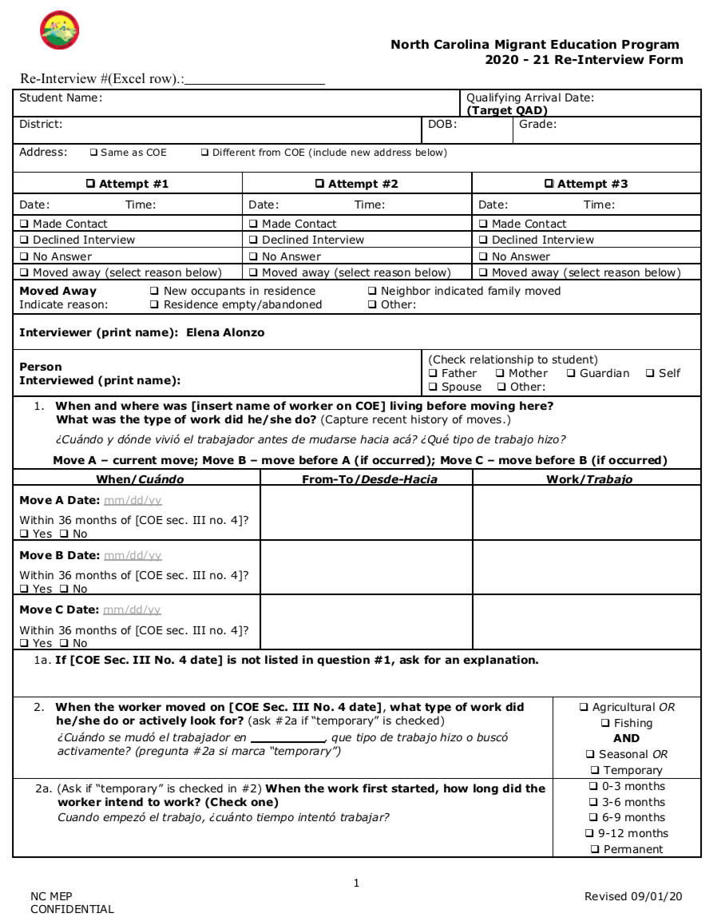

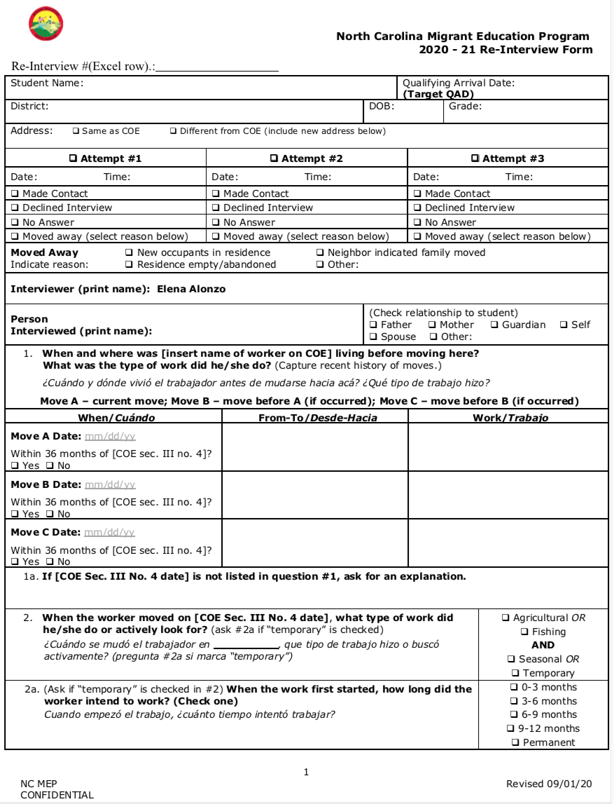
Appendix B – Information for CSPR Part II, Section 2.4.3

2.4.3 Child Count Calculation and Validation Procedures

The following questions request information on North Carolina’s MEP child count calculation and validation procedures.

2.4.3.2 Quality Control Processes

In the space below, describe the results of any re-interview processes used by the SEA during the performance period to test the accuracy of the State’s MEP eligibility determinations.

Results | #
The number of eligibility determinations sampled. | 150
The number of eligibility determinations sampled for which a re-interview was completed. | 51
The number of eligibility determinations sampled for which a re-interview was completed and the child was found eligible. | 50

Procedures
What was the most recent year that the MEP conducted independent prospective re-interviews (i.e., interviewers were neither SEA nor LEA staff members responsible for administering or operating the MEP, nor any other persons who worked on the initial eligibility determinations being tested)? If independent prospective re-interviews were not administered in any of the three performance periods, please provide an explanation in the “Comment” row at the end of this table. | SY 2019-20  □ SY 2018-19  □ SY 2017-18
Comment:
N/A

FAQ on independent prospective re-interviews:

- What are independent prospective re-interviews? Independent prospective re-interviews allow confirmation of your State’s eligibility determinations and the accuracy of the numbers of migratory children in your State reports. Independent prospective interviews should be conducted at least once every three years by an independent interviewer, performed on the current year’s identified migratory children.

Obtaining Data from Families | Yes | No
Check the applicable box to indicate how the re-interviews were conducted:
- Face-to-face re-interviews
- Phone Interviews
- Both
Was there a protocol for verifying all information used in making the original eligibility determination? | Yes | □ No
Were re-interviewers independent from the original interviewers? | Yes | □ No

If you did conduct independent re-interviews in this reporting period, describe how you ensured that the process was independent. Only enter a response if your State completed independent re-interviews in SY2019-20.

The response is limited to 8,000 characters.

The NC-MEP contracted an external agency (Arroyo Research Services) to implement the state’s external re-interview for the 2019-2020 performance period. Re-interviews were conducted by one external re-interviewer based in NY. The re-interviewer has no connection with migrant families from North Carolina or the NC MEP and was not involved in any of the original eligibility determinations in the sample.

The re-interviews then were reviewed by a panel that included 3 out of state ID&R experts. The review from the experts added an extra layer of independence to the process.

The randomly selected statewide sample included 50 “main” and 100 “alternate” names of students for whom an eligibility determination had been during the 2019-20 performance period.

In the space below, refer to the results of any re-interview processes used by the SEA, and if any of the migratory children were found ineligible, describe those corrective actions or improvements that will be made by the SEA to improve the accuracy of its MEP eligibility determinations.

The response is limited to 8,000 characters.

The North Carolina MEP re-interview for the 2019-2020 performance period was conducted in September and October. This external re-interview was completed in December of 2020. All interviews were completed by phone because of the Covid-19 pandemic. Fifty-one (51) interviews were completed by the external re-interviewer. An independent review panel reviewed the documentation. The panel met and made determinations that 50 out of the 51 eligibility determination were correct and eligible. One re-interview was deemed ineligible. Based on the work completed the independent review team determined an error rate of less than 2% for the State.

The NC MEP followed the following corrective actions for the student incorrectly identified as migrant eligible for the 19-20 performance period.

- Inform the family that the child is not eligible for the NC MEP.
- Cease services for any child on the ineligible COE
- Take the appropriate steps to remove from the local database the migrant status or other program eligibility indicators for the migrant students affected
- Ensure the information on MSIX is corrected
- Do not include the child(ren) in the state’s migrant child count.

In the space below, please respond to the following question:

Does the state collect all the required data elements and data sections on the National Certificate of Eligibility (COE)? | Yes | □ No

