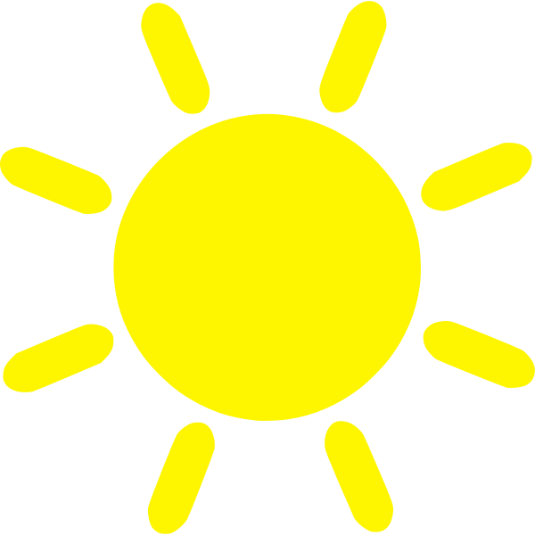
Sun

Make the sun with Playdough.

