(Insert MEP and/or LEA Logo Here)

Name: _____________________________ Date: ____________________

Directions: 1 point for each correct.

Alphabet Recognition: (26 points)
Uppercase
A | E | I | Q | H | V | O
Y | N | J | B | R | D | G
L | U | Z | W | P | M | X
S | C | F | K | T

Lowercase (26 points)
a | e | i | q | h | v | o
y | n | j | b | r | d | g
l | u | z | w | p | m | x
s | c | f | k | t

Colors: (11 points)
Black | Pink | Orange | Red | Green | Yellow
Brown | White | Grey | Blue | Purple

Shapes: (5 points)
Circle | Square | Rectangle | Triangle | Oval

Number Recognition: (10 points)
4 | 8 | 10 | 6 | 1
3 | 5 | 2 | 7 | 9

Rote Counting: (10 points)
1 2 3 4 5 6 7 8 9 10

Tracing: (3 points)
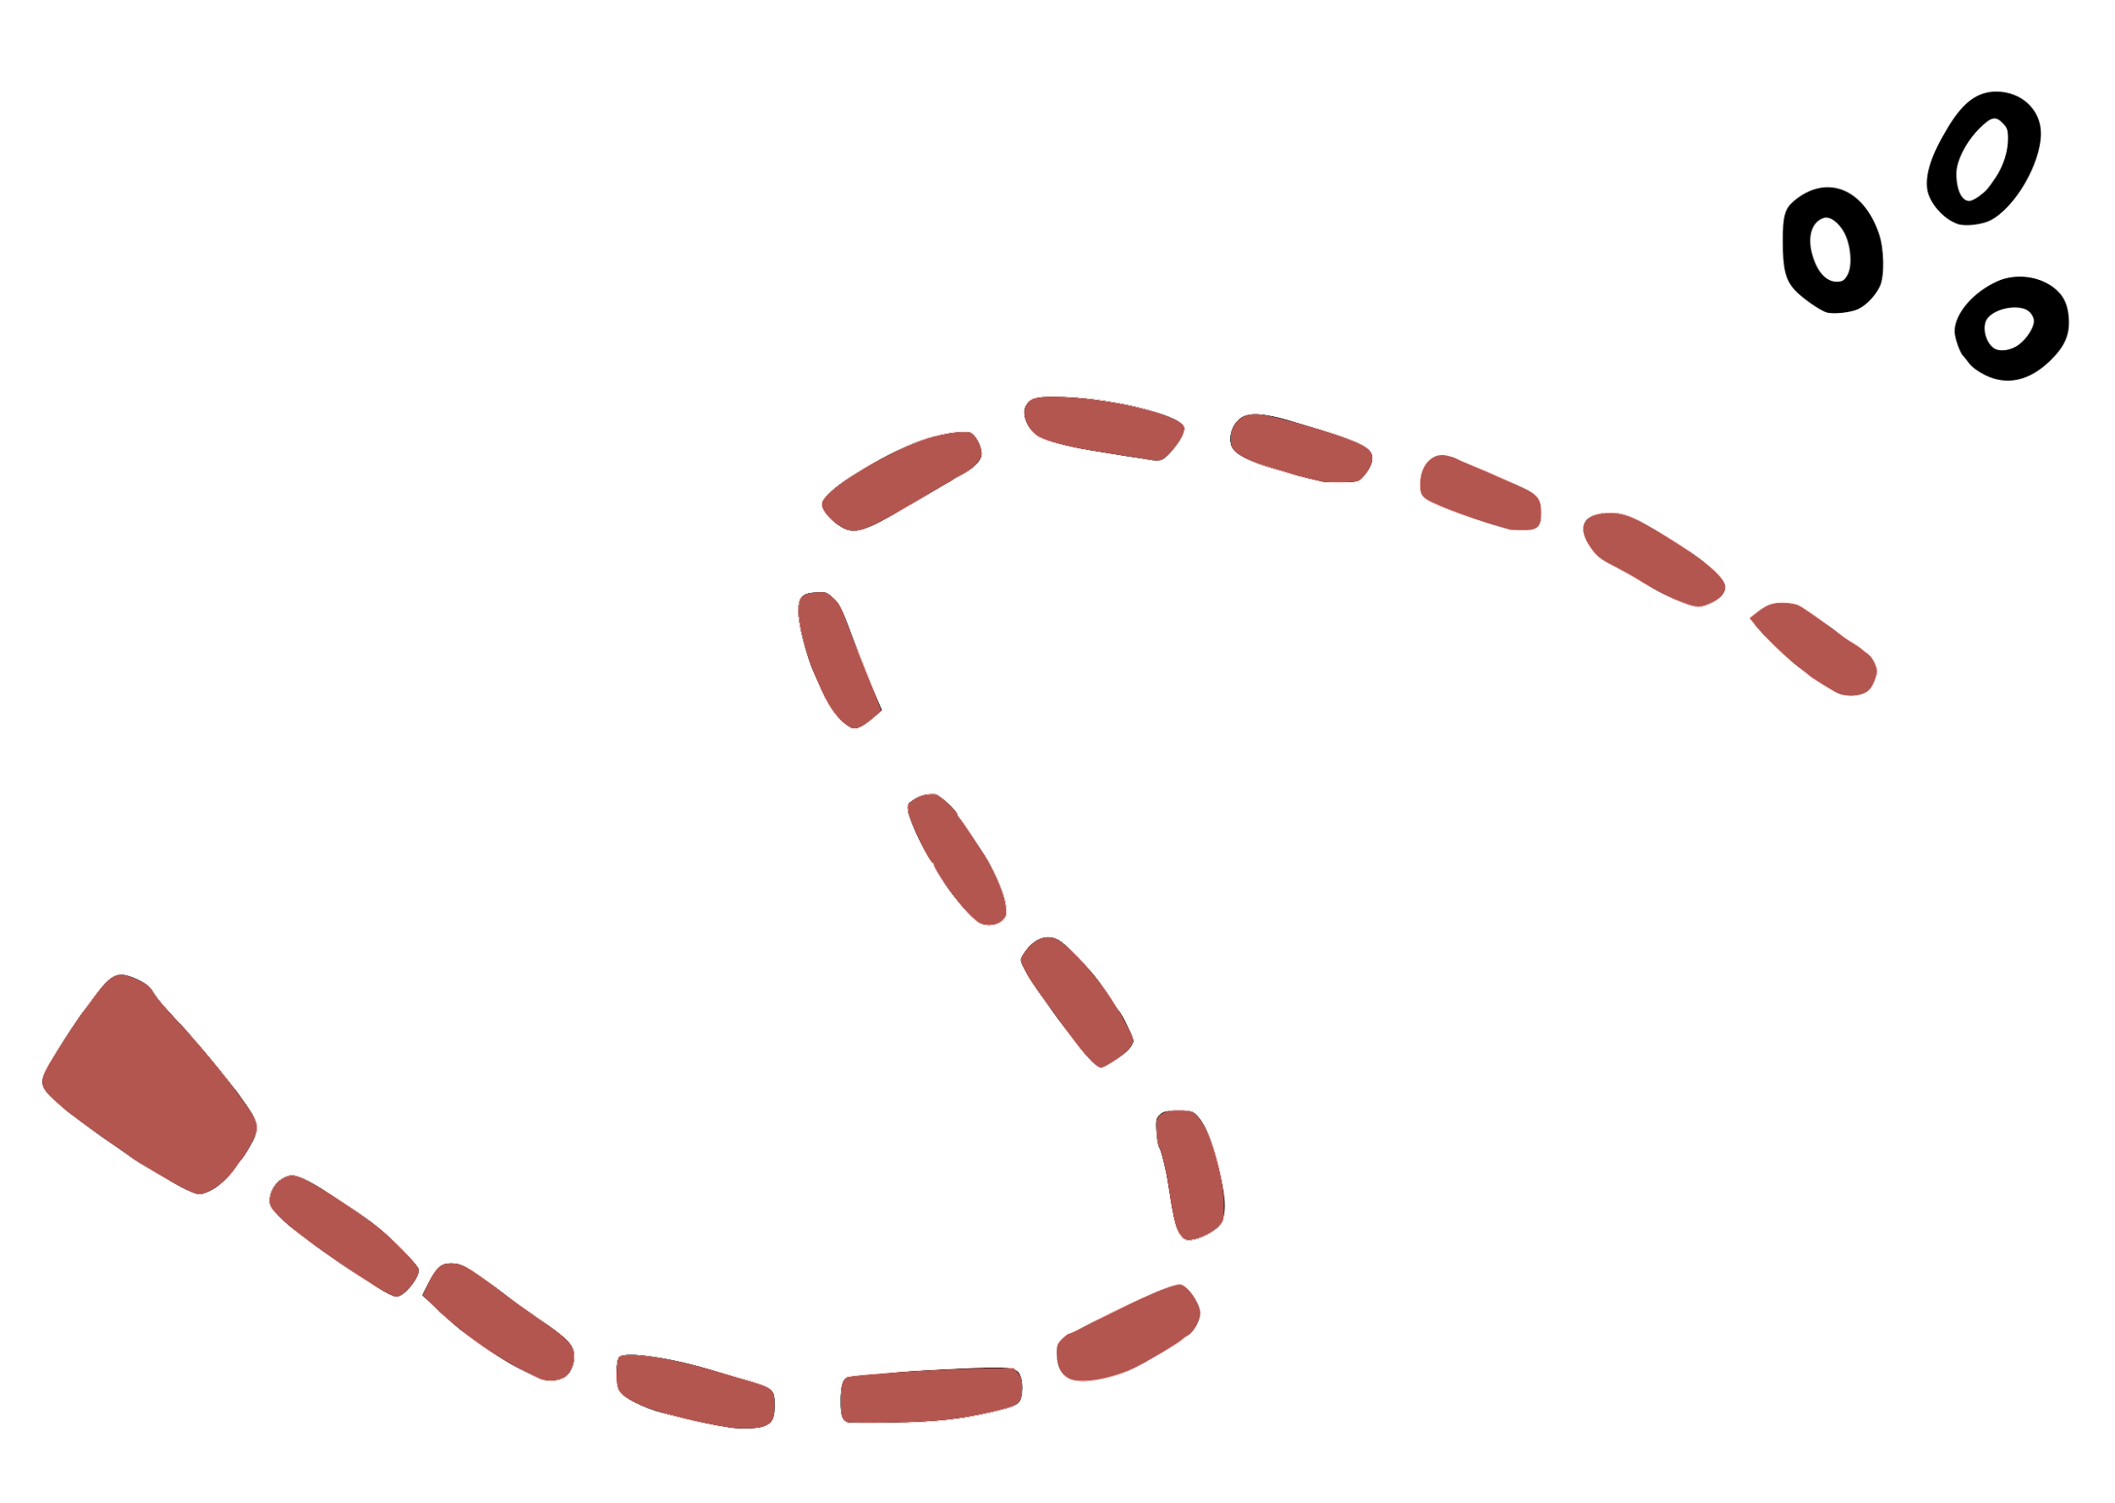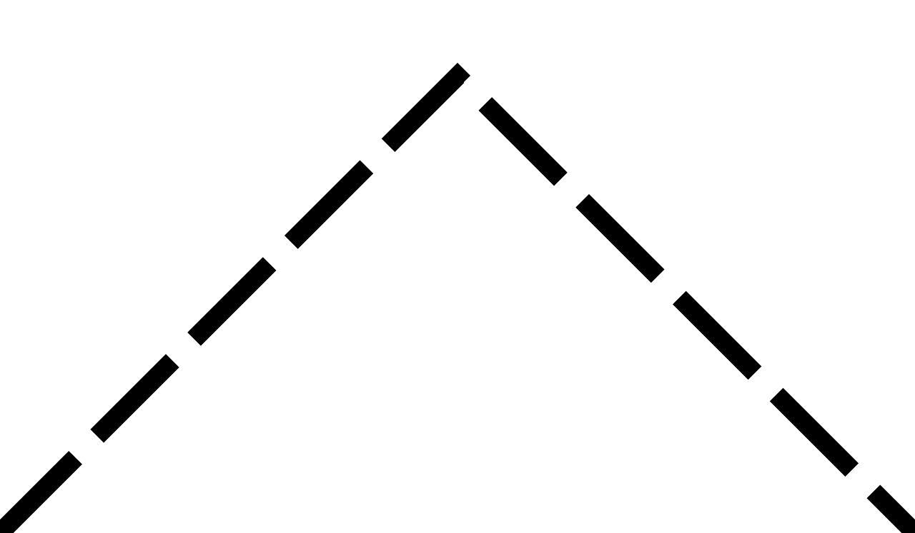

Holds pencil correctly? (1 point)
Writes Name? (2pts) _______________________________________________
Understands opposite words? (6 points)
- Fast
- Slow
- Big
- Small
- Happy
- Sad

100 points = 100 % ___________%

